**GamePad - Concept Development**

Emily Kaszubowski

**Part I: Ideation**

1. **Describe the overall idea behind your game:**

*Vile Dr. Vet* is a situational based video game where the protagonist dog Leo has to escape a corrupted vet clinic where he has been captured! He has to navigate through the clinic rooms until he makes it out to his unsuspecting owner’s car outside. Evading the vets, receptionists, and other animals will be a challenge Leo will conquer through careful navigation, distractions, and of course puppy eye power!

1. **Cite three references for your game and the influence they will have on your game concept. Support your descriptions with visuals.**

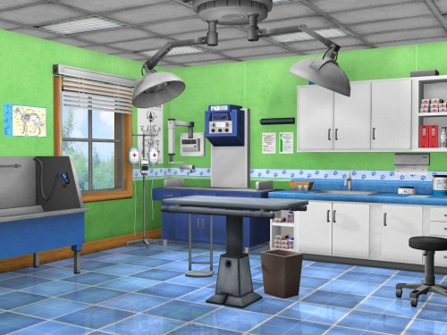

1. Animal Planet: Vet Life – Nintendo Wii

This game had a great layout of a vet room and will help me remember what contraptions I can put in each room. I will most likely put the bath and grooming things in a different room but the layout for the room where Leo has to evade the Vet should be similar to this room.

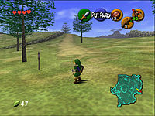

1. Legend of Zelda: Ocarina of Time

I really like how there is a map in the bottom right corner of this game. I want the room the player is in to take up the entire screen (because the screen is small) but I still want the player to know where they are in respect to other rooms in the clinic.

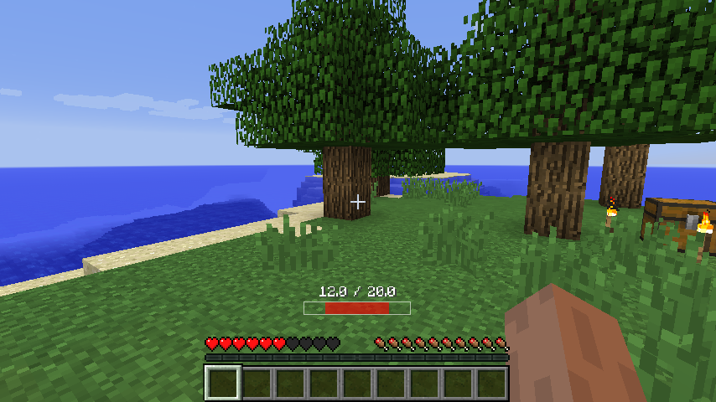

1. Minecraft

I want to have a health bar in some capacity. I like the hearts because they are a good indicator of heath that everyone (even the less savvy video game players) will be able to understand.

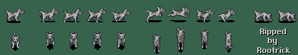**3. Create at least 3 characters for your game using reference images and sketching as necessary.**

Inspiration for main character!!!

Dog

https://www.spriters-resource.com/snes/secretevermore/sheet/150205/

Cat

https://forums.rpgmakerweb.com/index.php?threads/need-a-recolor-wings-added-to-this-cat-sprite.59716/

Mad Veterinarian that I made in Chris’s class

**4. Create at least 6 playing areas for your game and include the scans below.**

**5. Describe the controls that will help the user interact with the game (the GamePad includes 1 analog joystick and 4 push button controls)**

|  |  |
| --- | --- |
| **Controller Interactions** | |
| Joystick X | Leo walks to the left and right |
| Joystick Y | Leo walks up and down |
| Button A | Activates puppy eye mode |
| Button B | Shakes tail aggressively (weapon) |
| Button C | Play dead mode |
| Button D | Opens doors/picks up things |